Kyle Evangelisto

Prof Weissman

2020 November 11

OOPDA

Lab 12-A

1. Rewrite the printList() method to use a lambda:

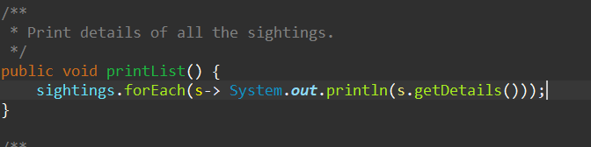

1. Rewrite the printSightingsOf() method in the AnimalMonitor class to use a stream and lambdas in a pipeline [Hint: stream(), then filter, then forEach...]

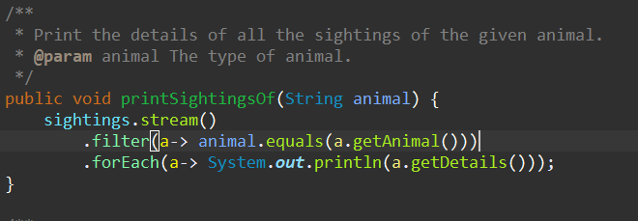

1. Rewrite the printSightingsBy(...) method to use a stream and lambdas in pipeline with a map [Hint: stream(), then filter, map, then forEach...]

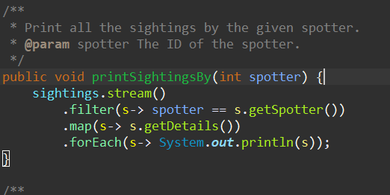

1. Rewrite getCount(....) For a specific animal, total the sightings and reduce. Display one number as the total of all sightings. [Hint1: stream(), then filter, Map, then reduce] [Hint2: reduce “returns” a value, so assign the pipeline’s return value to a variable; e.g.: int count = something.stream() ...//more operations ..reduce(................);

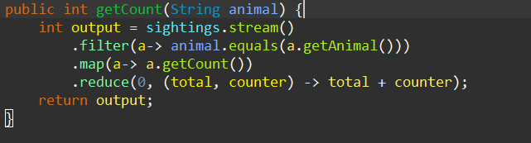

\*\*Did not attempt the challenge D\*\*

Sample output after methods were re-written:

